Estimating Based on Related Data

Definition
# Source: AI Source: Provided by: [Data Path: Persons Table -> ID Column: 1, Name_En Column: Motasem Essam] -> From: [Chatgpt (GPT‑5 Mini)] on [12/10/2025]
Estimating Based on Related Data is a method used in data cleaning where missing values are estimated using other related fields or patterns in the dataset.
- Instead of deleting the record or using a default value, the missing value is predicted using relationships between variables.
- This method is often used in data analysis, statistics, and machine learning.
Key idea:
It is like guessing a student’s likely score based on their study hours or past performance.

Characteristics
# Source: AI Source: Provided by: [Data Path: Persons Table -> ID Column: 1, Name_En Column: Motasem Essam] -> From: [Chatgpt (GPT‑5 Mini)] on [12/10/2025]
- Uses relationships between different variables in the dataset
- Often applied when other relevant data is available
- Can use patterns, correlations, or predictive models
- Helps keep the dataset complete and meaningful
- Common in advanced data preprocessing and analytics

Example
# Source: AI Source: Provided by: [Data Path: Persons Table -> ID Column: 1, Name_En Column: Motasem Essam] -> From: [Chatgpt (GPT‑5 Mini)] on [12/10/2025]
Original dataset:
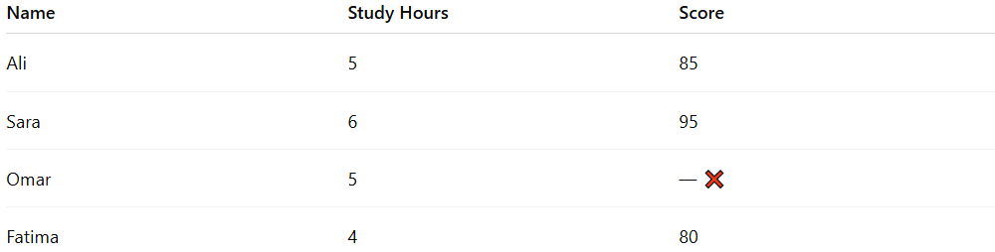
Name | Study Hours | Score
Ali | 5 | 85
Sara | 6 | 95
Omar | 5 | — ❌
Fatima | 4 | 80
Observation:
- Students who studied 5 hours scored around 85.
Estimated value:
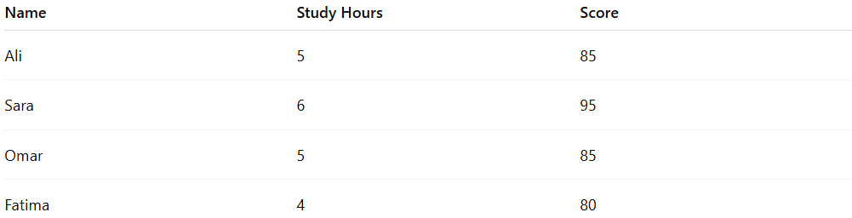
Name | Study Hours | Score
Ali | 5 | 85
Sara | 6 | 95
Omar | 5 | 85
Fatima | 4 | 80
Omar’s score is estimated based on similar study hours.

Example Section
# Source: AI Source: Provided by: [Data Path: Persons Table -> ID Column: 1, Name_En Column: Motasem Essam] -> From: [Chatgpt (GPT‑5 Mini)] on [12/10/2025]
A school database contains student information, but one student's score is missing.
Before cleaning:
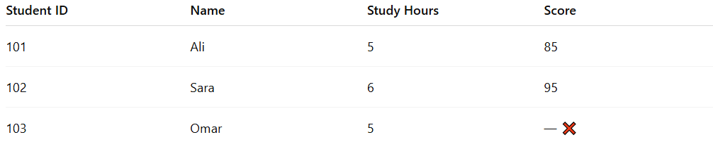
Student ID | Name | Study Hours | Score
101 | Ali | 5 | 85
102 | Sara | 6 | 95
103 | Omar | 5 | — ❌
Cleaning process:
- Analyze the relationship between study hours and scores.
- Estimate Omar’s score based on students with similar study hours.
After cleaning:
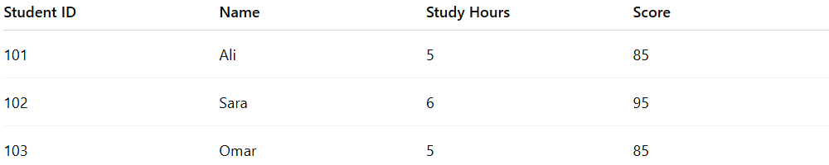
Student ID | Name | Study Hours | Score
101 | Ali | 5 | 85
102 | Sara | 6 | 95
103 | Omar | 5 | 85
This allows the dataset to remain complete while using realistic estimates.

Advantages
# Source: AI Source: Provided by: [Data Path: Persons Table -> ID Column: 1, Name_En Column: Motasem Essam] -> From: [Chatgpt (GPT‑5 Mini)] on [12/10/2025]
- Produces more realistic values compared to default replacements
- Maintains dataset completeness and structure
- Uses relationships within the data for better estimation
- Useful for advanced analysis and predictive modeling

Disadvantages
# Source: AI Source: Provided by: [Data Path: Persons Table -> ID Column: 1, Name_En Column: Motasem Essam] -> From: [Chatgpt (GPT‑5 Mini)] on [12/10/2025]
- Requires understanding relationships between variables
- Estimates may still differ from the true value
- Can be complex to implement for large datasets
- Incorrect assumptions may introduce bias or errors

